**Project Design Phase-II**

**Technology Stack (Architecture & Stack)**

|  |  |
| --- | --- |
| Date | 03 October 2022 |
| Team ID | PNT2022TMID27274 |
| Project Name | Project - Customer Care Registry |
| Maximum Marks | 4 Marks |

**Technical Architecture:**

The Deliverable shall include the architectural diagram as below and the information as per the table1 & table 2

**Example: Order processing during pandemics for offline mode**

**Reference**: <https://ieeexplore.ieee.org/abstract/document/9125430>

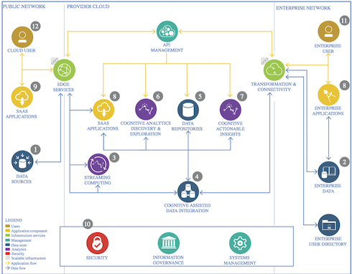

Guidelines:

1. **Offer excellent quality products and services.**
2. **Give customers multiple ways to get help.**
3. **Check for comments and feedback.**
4. **Remain calm and never argue with a customer.**
5. **Respond promptly to all feedback.**
6. **Be courteous and respectful.**

**Table-1: Components & Technologies:**

|  |  |  |  |
| --- | --- | --- | --- |
| **S. No** | **Component** | **Description** | **Technology** |
|  | User Interface | Point of human computer interaction | Communication in a device |
|  | Application Logic-1 | Application specific coordination of domain | Python/java |
|  | Application Logic-2 | Application specific infrastructure components | Watson STT service |
|  | Application Logic-3 | Organizes application into physical computer tiers | C++/C |
|  | Database | Organizes collection | DBMS |
|  | Cloud Database | Database designed from the ground | Cloud computing |
|  | File Storage | Hierarchical storage methodology | Click up, Smartsheet |
|  | External API-1 | Allow you to access third party resources REST | Development project |
|  | External API-2 | Allow you to access third party resources REST | HTTP Requests |
|  | Machine Learning Model | Purpose of Machine Learning Model | Object Recognition Model, etc. |
|  | Infrastructure (Server / Cloud) | Local Server Configuration: Create  Cloud Server Configuration: Computing | URL Address to access it  URL Address to access them |

**Table-2: Application Characteristics:**

|  | **Characteristics** | **Description** | | **Technology** |
| --- | --- | --- | --- | --- |
|  | Open-Source Frameworks | Template for software development | | Technology framework for public |
|  | Security Implementations | Inventory and manage assets | | Linux and UNIX |
|  | Scalable Architecture | Supports higher workloads | | A set of software |
|  | Availability | Quality or start of being available | Purposeful intervention by design | |
| 5. | Performance | Action process of performance in task | Inform stakeholders of proficiency | |

**References:**

[**https://ieeexplore.ieee.org/abstract/document/8029379**](https://ieeexplore.ieee.org/abstract/document/8029379)

[**https://ieeexplore.ieee.org/abstract/document/755466**](https://ieeexplore.ieee.org/abstract/document/755466)

[**https://ieeexplore.ieee.org/abstract/document/4801621**](https://ieeexplore.ieee.org/abstract/document/4801621)

[**https://ieeexplore.ieee.org/abstract/document/8977439**](https://ieeexplore.ieee.org/abstract/document/8977439)

[**https://ieeexplore.ieee.org/abstract/document/7814394**](https://ieeexplore.ieee.org/abstract/document/7814394)